AI ASSISTED CODING
ASSIGNMENT - 10
NAME: P.SAI SHANKAR
HL-NO: 2303A52500 BATCH: 50
Lab 10.3:
Task-1 :
Prompt : "Implement a review of this Python function for calculating factorials. Identify any logical errors, explain why they occur, provide a corrected version, and check if it handles edge cases like negative numbers and zero.
Code:
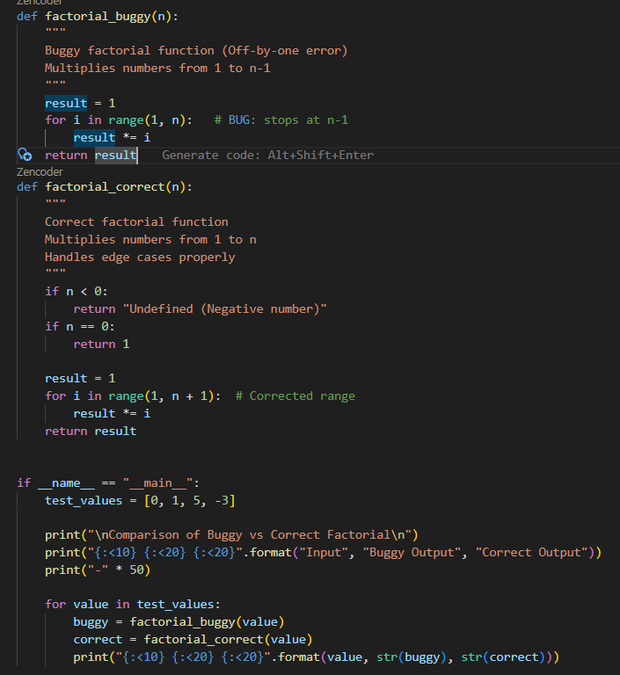
Output :
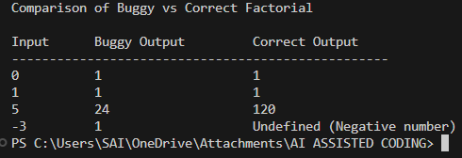

Task-2 :
Prompt : "Implement a review of the following Python function, focusing on its readability, parameter naming, and lack of documentation. Critique the function and then rewrite it with descriptive names, a complete docstring, exception handling for division by zero, and input validation.
Code:
# ------------------ Wrong Version ------------------
def calc(a, b, c):
if c == "add":
return a + b
elif c == "sub":
return a - b
elif c == "mul":
return a * b
elif c == "div":
return a / b # No division by zero check
# No handling for invalid operations

# ------------------ Improved Version ------------------
def calculate(num1, num2, operation):
"""
Perform basic arithmetic operations safely.
"""
if not isinstance(operation, str):
raise TypeError("Operation must be a string")
operation = operation.lower()
if operation == "add":
return num1 + num2
elif operation == "sub":
return num1 - num2
elif operation == "mul":
return num1 * num2
elif operation == "div":
if num2 == 0:
raise ZeroDivisionError("Cannot divide by zero")
return num1 / num2
else:
raise ValueError("Invalid operation")
# ------------------ Testing Both ------------------
if __name__ == "__main__":
test_cases = [
(10, 5, "add"),
(10, 0, "div"),
(10, 5, "power"),
(10, 5, 123)
]
print("\nComparison of Wrong vs Improved Function\n")
print("{:<20} {:<20} {:<20}".format("Input", "Wrong Output", "Improved Output"))
print("-" * 70)
for a, b, op in test_cases:
# Test wrong function safely
try:
wrong_result = calc(a, b, op)
except Exception as e:
wrong_result = type(e).__name__
# Test improved function safely
try:
improved_result = calculate(a, b, op)
except Exception as e:
improved_result = type(e).__name__
print("{:<20} {:<20} {:<20}".format(
f"({a},{b},{op})",
str(wrong_result),
str(improved_result)
))

Output :
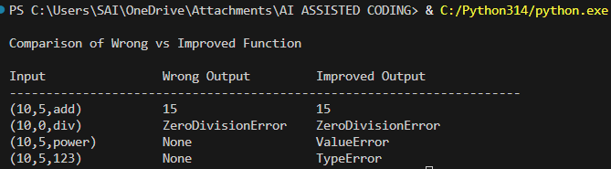

Task-3 :
Prompt : "Implement a review of the following Python function to ensure PEP8 compliance. Verify that the function works correctly for sample inputs, then use an AI tool to list all PEP8 violations and refactor the code, including changes to the function name, spacing, indentation, and variable naming.
Code:
# ------------------ Wrong Version ------------------
def Checkprime(n):
for i in range(2, n):
if n % i == 0:
return False
return True

# ------------------ PEP8 Compliant Version ------------------
def check_prime(n: int) -> bool:
"""
Check whether a number is a prime number.
Parameters:
n (int): The number to check.
Returns:
bool: True if n is prime, False otherwise.
"""
if not isinstance(n, int):
raise TypeError("Input must be an integer.")
if n < 2:
return False
for i in range(2, n):
if n % i == 0:
return False
return True
# ------------------ Testing Both ------------------
if __name__ == "__main__":
test_values = [1, 2, 5, 10, -3, 7.5]
print("\nComparison of Wrong vs PEP8-Compliant Function\n")
print("{:<10} {:<20} {:<20}".format("Input", "Wrong Output", "Correct Output"))
print("-" * 60)
for value in test_values:
# Test wrong function safely
try:
wrong_result = Checkprime(value)
except Exception as e:
wrong_result = type(e).__name__
# Test correct function safely
try:
correct_result = check_prime(value)
except Exception as e:
correct_result = type(e).__name__
print("{:<10} {:<20} {:<20}".format(
str(value),
str(wrong_result),
str(correct_result)
))

Output :
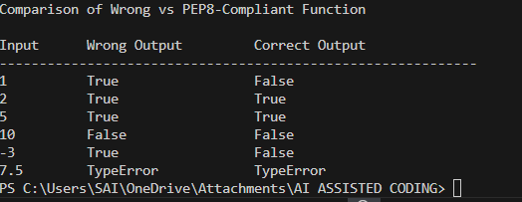

Task-4 :
Prompt : "Implement a review of the following Python function, focusing on its readability, naming, reusability, modularity, and edge cases such as non-list input, empty lists, and non-integer elements
Code:
# ------------------ Wrong Version ------------------
def processData(d):
return [x * 2 for x in d if x % 2 == 0]

# ------------------ Improved Version ------------------
from typing import List, Union
def double_even_numbers(numbers: List[Union[int, float]]) -> List[Union[int, float]]:
if not isinstance(numbers, list):
raise TypeError("Input must be a list")
return [
num * 2
for num in numbers
if isinstance(num, (int, float)) and num % 2 == 0
]
# ------------------ Testing Both ------------------
if __name__ == "__main__":
test_cases = [
[1, 2, 3, 4],
[],
"hello",
[2, "a", 4, 5]
]
print("\nComparison of Wrong vs Improved Function\n")
print("{:<25} {:<25} {:<25}".format("Input", "Wrong Output", "Improved Output"))
print("-" * 80)
for case in test_cases:
# Test wrong function safely
try:
wrong_result = processData(case)
except Exception as e:
wrong_result = type(e).__name__
# Test improved function safely
try:
correct_result = double_even_numbers(case)
except Exception as e:
correct_result = type(e).__name__
print("{:<25} {:<25} {:<25}".format(
str(case),
str(wrong_result),
str(correct_result)
))

Output :
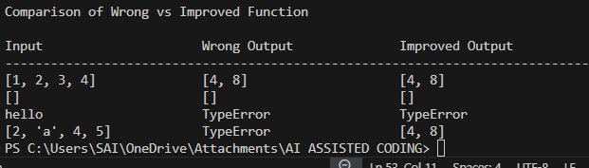

Task-5 :
Prompt : Implement a review of the following Python function that processes a list of integers, focusing on performance optimization
Code:
import time

# ------------------ Original Version ------------------
def sum_of_squares(numbers):
total = 0
for num in numbers:
total += num ** 2
return total
# ------------------ Optimized Version ------------------
def sum_of_squares_optimized(numbers):
return sum(x * x for x in numbers)
# ------------------ Testing Performance ------------------
if __name__ == "__main__":
large_data = range(1000000)
# Measure original time
start = time.time()
original_result = sum_of_squares(large_data)
original_time = time.time() - start
# Measure optimized time
start = time.time()
optimized_result = sum_of_squares_optimized(large_data)
optimized_time = time.time() - start
print("\nPerformance Comparison\n")
print("{:<25} {:<20} {:<15}".format("Function", "Result", "Time (seconds)"))
print("-" * 65)
print("{:<25} {:<20} {:<15}".format(
"Original Version",
original_result,
round(original_time, 5)
))
print("{:<25} {:<20} {:<15}".format(
"Optimized Version",
optimized_result,
round(optimized_time, 5)
))

Output :
